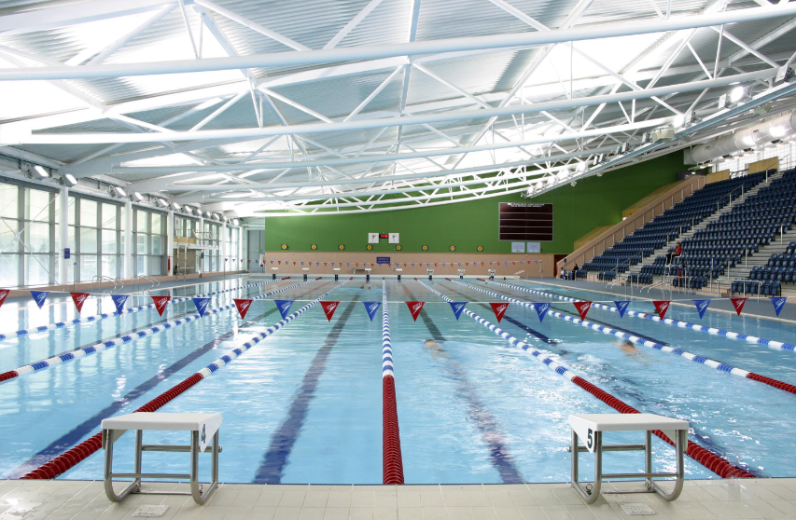  SLSA Wales Stillwater safeguarding plan  Last Updated April 2024 | 

Index
Glossary Page 2
Safeguarding Page 2
Scope of Document Page 2
Purpose of the Event Safeguarding Plan Page 3
Principles of the Document Page 3
Principles of participation for Children and Young People Page 3
Principles of Participation for any Adults With an Event Role Page 4
Venue Information Page 4
Dissemination of safeguarding Information Prior to Event Page 4
Adult Safeguarding Volunteer Requirements for the Event Page 5
What Should be Reported Page 5
Emergency Procedures Page 7
Medical Provision Page 7
Care of Athlete Page 7
Supervision Ratios Page 7
Photography and Media Page 8
Parent and Spectator Photography, Tannoy Statement Page 8
No Photography in Changing Village Poster Page 8
Missing Persons Flowchart Page 12

Julie Wisden – Lead Safeguarding Officer, Surf Life Saving Association of Wales / 07853 000457
safeguarding@slsawales.org.uk

The following Codes of Conduct can be found in the Safeguarding section of the SLA Wales website under key Codes of Conduct

Appendix 1 – SLSA wales Code of Conduct
Appendix 2 – Parent Code of Conduct
Appendix 3 – Youth Code of Conduct
Appendix 4 – Officials Code of Conduct
Appendix 5 – Anti Bullying Policy
Appendix 12 – Social Media Code of Conduct

SLSA WALES – main website

Safeguarding Docs (slsawales.org.uk) – Safeguarding Section

Child or Young Person | Defined as a person under the age of 18 as defined in the Social Services and Wellbeing Act (Wales) Act 2014.
Child protection | Process of protecting individual children identified as either suffering or at risk of suffering significant harm.
Codes of Conduct | Clearly stated expectations of the standard of behaviour for athletes and the staff and volunteers fulfilling these roles at SLSA wales Stillwater events.
CPSU | NSPCC Child protection in Sport Unit
DBS | Generic term referring to all home county criminal record processes (Disclosure and Barring Service)
Duty of Care | The legal and moral responsibility that we all have to keep children and vulnerable adults safe.
LADO | Local Authority Designated Officer
LSCB | Local safeguarding Childrens Board
NGB | National Governing Body
NSPCC | National Society fo0r the Prevention of Cruelty to Children
Parents | A generic term to represent a person or people with legal parental responsibility for a child or young person.
SLSA Wales | Surf Life Saving Association of wales
Staff | A generic term that includes all volunteer staff
SW | Stillwaters

Safeguarding
This safeguarding plan is designed to minimise the risks to young people taking part and to maximise their enjoyment and wellbeing.
In order to achieve this all staff involved in the organisation, set up, welfare, coaching, supporting and volunteering at the Stillwaters competition are required to read the Safeguarding Plan carefully and to fulfil their respective responsibilities in order to ensure that all the procedures are followed in a consistent and coordinated manner.
Whilst most children and young people thoroughly enjoy their sport and the camaraderie that goes with it and attending competitions, some experience disruption and others bring with them the impact of issues at home or at school. This safeguarding plan identifies the challenges faced in terms of safeguarding at the event and provides clarity on conduct and procedures in the event of a concern arising.

Scope of Document
This safeguarding document applies to all Organisers, Officials, Coaches, Team Captains Parent Helpers and Volunteers who are responsible for the care of children attending this competition. A child is defined as a person under the age of 18 years (The Children Act 2004).
Safeguarding is all of ours’ responsibility

Purpose of the Safeguarding Plan
The purpose of the Safeguarding Plan is to promote and ensure the well-being of those young people taking part in the SLSA Wales Stillwaters competition.
The plan will also ensure that
- all those responsible for the welfare of children and young people understand their safeguarding role and responsibilities.
- Are suitably advised on their responsibilities to our young members
- Understand the procedures for responding to concerns about children’s welfare.
- Are able to act on these appropriately and effectively.
- Minimise the risk to athletes and team staff
- Encourage the enjoyment of all involved
- Maximise the opportunity for all children and young people to participate to the best of their ability

“The Welfare of the Child is paramount”

The plan identifies the challenges faced at the event in terms of safeguarding and provides clarity on conduct and procedures in the event of a concern arising.
The plan is specific to this event and at all times the SLSA Wales Safeguarding Children Policy will be followed and referred to.
The Stillwater Safeguarding Plan is specific to the Stillwaters and not a standalone product. At all times the SLSA Wales Child Safeguarding Policy will be followed and referred to. A copy of this can be found at
Safeguarding Docs (slsawales.org.uk)

Principles of Document
The Stillwater competition Safeguarding Plan is underpinned by the following principles:
- The welfare of all children attending at the Stillwaters is paramount
- All competitors and young volunteers, whatever age, gender, culture, language, racial origin, religious beliefs, sexual identity or disability have equal rights to safety and protection from harm.
- All suspicions of concern or allegation of harm arising from the Stillwater competition, within or outside the sport, will be taken seriously and responded to appropriately.

Person with Lead Responsibility
Your event organiser is Simon Perry. Any concerns regarding the sport of surf lifesaving during this competition or the immediate physical safety, welfare of competitors need to be brought to his attention immediately.

Principles of Participation for Children and Young People
While these principles mainly apply to the athlete, it is important that parents, carers, staff and volunteers are also aware of and promote them
Fun
- Children have a right to enjoy their participation in the event

Fair play
- Treat everyone with the same respect and fairness that you would like to be shown
- Stick to the rules of the event and your sport and don’t encourage foul play or bad sportsmanship
- Challenge or speak out about behaviour that falls below the expected standards
- Demonstrate fair play at all times
- Respect differences in gender, disability, culture, race, ethnicity, and religious belief.
- Appreciate that all participants bring something valuable and different to the event
- Show patience to competitors, volunteers and all in attendance
- Challenge discrimination and prejudice
- Do not engage in or condone bullying of any kind
- Be responsible, look out for yourself and the welfare of others
- Do not take part in any irresponsible, inappropriate, abusive or illegal behaviour
- Be organised and be on time for your events
- Take time to thank those who help you compete and take part, whether your family, coach or teammates.

Principles of Participation for any Adults With Any Event Role
A Code of Conduct for staff and volunteers at any sports event should include four principles:

Rights: Staff / volunteers working at any event must respect the rights of children and young people, promoting their welfare and their individual needs.

Relationships: Staff / volunteers should promote relationships with participants and others that are based on respect, openness, honesty and trust. They must not engage with participants in behaviour that is abusive or inappropriate. They must respond to any concerns about a child’s welfare, and work in partnership with other organisations in the child’s best interests.

Responsibilities: Staff / volunteers must demonstrate proper personal / professional behaviour at all times, promoting positive role models for the children and young people they are working with. Staff must ensure that children are provided with a safe environment which maximises benefits and minimizes risks to them.

Equity: All staff / volunteers must demonstrate commitment to respecting differences between staff and participants in terms of gender, sexual orientation, race, ethnicity, disability, culture and religious belief.

Useful Venue Information
Pool name – Wales National Pool, Swansea
Telephone number – 01792 513 513
Address -
Swansea Bay Sports Park,
Sketty Lane,
Swansea
SA2 8QG

Dissemination of Safeguarding Information prior to the Event
The Club Safeguarding Officer is to ensure that all parents of competitors receive a copy of the safeguarding plan prior to competition.
The role of the team captain is to disseminate the information below to their team members prior to first event start.

The importance of this is that young members competing have sight of this document and understand the expected standards of behaviour. It would be unfair to not inform them of the standards expected of them and the possible consequences of non-adherence.

Adult Safeguarding Volunteer Requirements for the Stillwaters
All clubs are asked to provide a volunteer to act as Welfare Officer for their club. Organisers appreciate offers of help from parents however all volunteer staff acting as Welfare Officers for their clubs are required to hold a current DBS check. Club Safeguarding Officers are to ensure that all volunteers hold a current DBS certificate.

Volunteer Safeguarding Officer Brief

What Should Be Reported
In order to provide a clear guide of safeguarding at the SLSA Wales Stillwaters and to ensure consistency throughout the event, the following information details what should be reported fro a safeguarding perspective.

Category A
- General concerns about a young person/s welfare.
- Any event or circumstance related to a child protection / safeguarding incident including bullying, poor practice and prejudicial behaviour
Suspicions or allegations of –
- Misconduct / breach of code of conduct made against any member of staff, volunteer or against the SLSA Wales Code of Conduct.
- Abuse made against any member of staff or volunteer or other party on site.
- Misconduct / breach of Code of Conduct / abuse made against an athlete, young official or young volunteer.
- Abuse within a child’s family or community abuse made against an athlete, young official or young volunteer.

Category B
- All accidents and incidents, no matter how trivial they might appear to be, should be reported.
- For example:
- Any injury to any part of a person’s body
- Any case requiring medical or first aid treatment
- Any circumstance which is believed could have resulted in bodily injury, illness, shock or other condition requiring immediate treatment.
- Any event or circumstance which resulted in, or in which it is believed could have resulted in, a person’s exposure to a substance hazardous to health.
- Any event or circumstance, which resulted in , or in which it is believed could have resulted in, damage to the site, equipment or personal property.

Reporting Procedures
All Team Managers / safeguarding support must complete a report if an injury, accident, incident or near miss occurs or if they have concerns in line with the above.

Copies of the Incident Report Form will be available from the Lead Safeguarding Officer in the location of the medals table.

If the incident occurs at the venue , the venue staff will require some f the information on the Accident / Incident Report form for their records.

All relevant forms are held with the event Safeguarding Lead Officer and Event Manager

Those reporting should not contact the Police / Ambulance / Childrens Services direct (except in an emergency for accidents and incidents) but contact their Team manager or event Safeguarding Lead Officer and Event Manager.

Recognise, Respond, Refer, Record

Recognise – You have a concern, notice a problem or receive a direct disclosure.

Respond – Reassure the individual, tell them what you will need to ask them for more information if they are ok to do that. It is important that this is done as soon as possible before recollection of events is lost. Locate the parents or team manager if they are not at the venue and then take the young person to a quiet location and ensure that you have another adult with you if you are waiting for parents, team manger / support to arrive.

Refer* – Make contact with the Lead Safeguarding Officer as soon as possible.

Record – Who, what, where, when – use the reporting form to record the information. Ask open questions using the 4 W’s and avoid putting words into the young person’s mouth. i.e.
Avoid asking questions that start with Did, Does or Was as these will tend to be leading questions.
Avoid asking Why as this can imply blame
Return to the info the young person has given and clarify details on the report form.
Ask the young person if there is anything else they would like to tell you.

*Refer if any of the following is reported
- If a child / young person has been accidentally or otherwise hurt.
- If a child / young person seems distressed in any manner
- If you receive a direct disclosure of alleged abuse from a child or young person.
- If you have any concerns at all even if they seem unclear
- If a child / young person needs to be restrained

Remember it is not your responsibility to decide whether or not a young person has been abused. It is however everyone’s responsibility to report any concerns in line with the procedures above.

Responding to a suspicion or allegation of inappropriate behaviour or misconduct.
If there is an allegation of abuse by a person in a position of trust within SLSA wales and it meets the threshold for referral to statutory agencies, this would be referred to the local LADO and investigated by the local Police and the relevant Children’s Social care Team.
If, however, the allegation refers to an incident that has occurred within the community in which the young person lives at home the agencies in that locality will be contacted.

Emergency Procedures
All staff and competitors will be made aware of emergency procedures and what to do in these events via tannoy announcement.
In the event of fire alarm activation at the pool venue, immediate evacuation is the mandatory response. From the venue, everyone should make their way immediately to the nominated assembly point under the direction of the Team Managers, support staff and Venue staff.

A specific evacuation plan will be followed and all staff and volunteers will be briefed as to the relevant evacuation procedures and will have the responsibility of ensuring that their team / competitors evacuate the building immediately if the alarm is evacuated.
At the assembly point, Team Managers or another nominated team member (if the team manager is absent), will complete a roll call and inform the person in charge of the evacuation of any individual unaccounted for, together with their last known location.

Athlete Registration
Team managers and support should have a system in place to track the number and name of any children and young peopple they have responsibility for at any point during the event. This is vital if someone is injured or if there is a major incident such as fire, whe you need to account for everyone.
On submission of entries each club should establish a contact list containing name of competitor, date of birth, medical concerns, allergies and parent contact details.
Ideally we would like parents to remain at events where their child is competing however we know this is not always possible due to work restraints etc.

Sample Registration Form

Medical Provision
Medical provision at the venue will be covered by pool staff at all times. There is a first aid room poolside and the duty lifeguards will take the lead on all medical incidents.

Care of Athlete
Once parents have handed their athlete over to the Team manager the duty of care for the athlete is transferred to the Team manager. It is important that the Team manager and a member of the support team has full contact details for the parents for the duration of the event, medical consent to act in loco parentis, photography consent, details of any medical conditions and mediation need.
For the purposes of toilet breaks, we respectfully ask that parents manage this themselves and competitors inform their team manager/ support staff that they are leaving the competition area.

The number of Team Managers and Team Support Staff will be a minimum ration of 1:10 (where the young people are under the age of 18 years) to the competitors and they will supervise the competitors at all times during the event. They will act in ‘loco parentis’ which means being responsible for a child while the parent/s choose to be absent from the event.

Collection of Children
Parents are responsible for collecting their children once the event has finished or to have made arrangements for their child / children to be collected.

To support Team Managers in safeguarding their teams, the following staff will be available

- The Lead Safeguarding Officer
- The Event Manager
- The Event Safety Manager

The event safeguarding team will be responsible for :

- Ensuring a safe environment at the competition venue
- Liaising with venue staff and other relevant individuals with a care role for the competitors such as Team Managers.
- Working in accordance of the safeguarding plan and managing any information that is passed via the safeguarding team.
- Being available to offer support to team staff outside competition time if needed.

Photography and Media
Photography and media provide an excellent opportunity to celebrate the achievement of young people and the excitement of the Stillwater Competition.
The information detailed in the event plan covers both the taking and use of photographs and images at the Stillwater competition and afterwards to safeguard children and young people.

Young people and parents will have completed a photography consent form via their Club Safeguarding Officer as part of SLSA Wales safeguarding procedures.
Club Safeguarding Officers will be asked to make any competitor known to the Team manager so that they may signpost the competitor to the Lead Safeguarding Officer. These details will be logged and no official photographs will be taken of these young people by the event photographers. Official photographers will be notified and those who have not given consent will be given a coloured wristband to wear so they are identifiable.

All photographers including event and club photographers will be required to sign a registration form undertaking to use any photographs / images in an appropriate manner.. All photographers that sign the declaration will be provided with an identification lanyard which will be worn at all times.

Parent and Spectator Photography
The following announcement will be made via tannoy prior to the start of the competition

Surf Life Saving Association of Wales – Appendix 18
Photography & Recorded Images Tannoy Statement

Please be advised that photography and video will be taken at this event.
These may be used as promotional material and used across public forums including Surf Life Saving Association of Wales websites and public social media accounts.
SLSA Wales are aware of the wide range of devices including mobile telephones, which have photographic and filming capabilities. This enables the capture of both static and moving images. Used responsibly, such devices are perfectly safe, but sharing images widely may betray a confidence or identity of a child / children which may present a risk of harm to the child / children concerned.

The use of cameras or any other equipment with the ability to capture images or video is strictly prohibited inside the changing village and we ask that all spectators and competitors adhere to this request. Non compliance may result in disqualification from the competition

The use of such equipment is difficult to control but we can all be vigilant. If you have any concerns in this area, or are concerned that images are being taken that are not in the context of the sport, please bring it to the immediate attention of the Event Organiser / Lead Safeguarding Officer present at this event.
We all have a duty to be vigilant. If you have any child safeguarding concerns please contact the Event Organiser / Lead Safeguarding Officer present at this event.

If you have any other queries please contact a member of the Events Team or Official.
We thank you for your co-operation
Surf Life Saving Association of Wales Safeguarding

Event Poster Advising that Photography and recorded Images Will be Taken at this Event

Surf Life Saving Association of Wales - Appendix 17
Event Photography Poster

FILM AND PHOTOGRAPHY POLICY



Please be advised that photography and video will be taken at this event.
These may be used as promotional material and used across public forums including Surf Life Saving Association of Wales websites and public social media accounts.

SLSA Wales are aware of the wide range of devices including mobile telephones, which have photographic and filming capabilities. This enables the capture of both static and moving images. Used responsibly, such devices are perfectly safe, but sharing images widely may betray a confidence or identity of a child / children which may present a risk of harm to the child / children concerned.

The use of such equipment is difficult to control but we can all be vigilant. If you have any concerns in this area, or are concerned that images are being taken that are not in the context of the sport, please bring it to the immediate attention of the Events Officer / Lead Safeguarding Officer present at this event.

The safety of children and young people for Surf Life Saving Association of Wales is of paramount importance. We all have a duty to be vigilant. If you have any child safeguarding concerns please contact the Events Officer / Lead Safeguarding Officer present at this event.

If you have any other queries please contact a member of the Events Team or Official

Event Poster Advising that Photography is Prohibited in the Changing Village

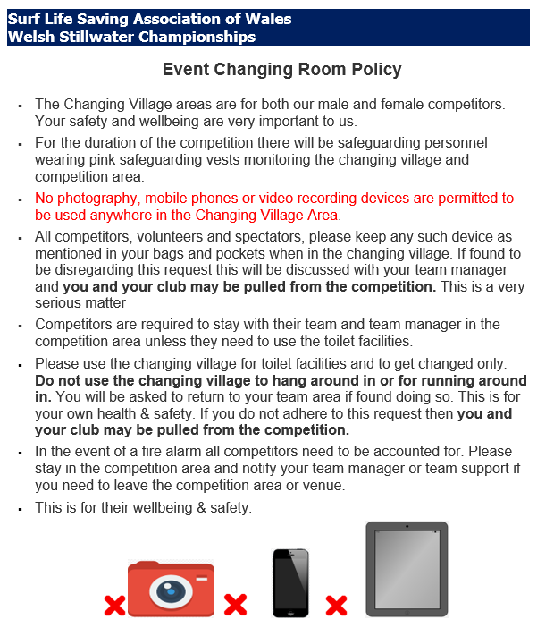

Missing Persons Process

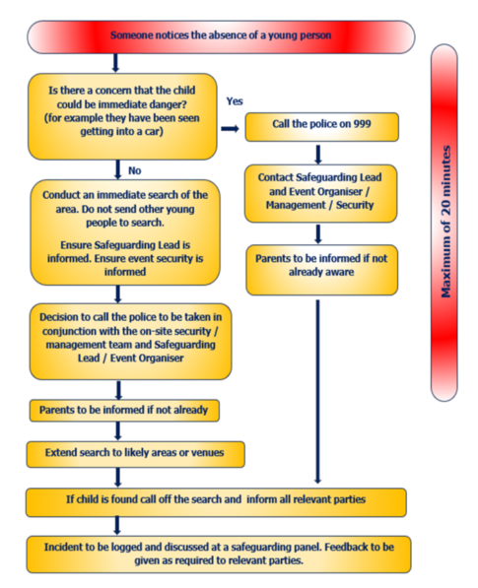

Thank you for your time in reading this safeguarding document.

